[Dissertation/Thesis TITLE (type the first line longer than the second line)]

[First name Last name (Do not enter the prefix)]

A Dissertation/Thesis Submitted in Partial
Fulfillment of the Requirements for the Degree of
Doctor or Master of [Name of Degree] ([Name of Program if available])
[School/Faculty Name]
National Institute of Development Administration
[Academic Year]

[Dissertation/thesis title (type the first line longer than the bottom line)]
[First name Last name (Do not enter the prefix)]
[School/Faculty Name]

[Academic Position] Major Advisor
([First name Last name, Degree])

[Academic Position] Co-Advisor
([First name Last name, Degree])

The Examining Committee Approved This Dissertation/Thesis Submitted in Partial Fulfillment of the Requirements for the Degree of [Name of Degree] ([Name of Program if available])

[Academic Position] Committee Chairperson
([First name Last name, Degree])

[Academic Position] Committee
([First name Last name, Degree])

[Academic Position] Committee
([First name Last name, Degree])

ABSTRACT
Title of Dissertation/Thesis [Title of Dissertation/Thesis]
Author [Mr./Mrs./Miss First name Last name]
Degree [Title of Degree] ([Program if available])
Year [Academic Year (numbers only)]

[Start here (1-2 pages]

[Do not delete the “Section Break” below, if you can’t see it, turn on Show/Hide (click to toggle the Show/Hide display on and off)]

ACKNOWLEDGEMENTS
[Start here (only page)]
[First name Last name]
[Month Year]

[Do not delete the “Section Break” below, if you can’t see it, turn on Show/Hide (click to toggle the Show/Hide display on and off)]

TABLE OF CONTENTS
Page

[Using Table of Content automatically:-
- Click on the “References” tab
- Go to “Table of Contents” group, click on “Table of Contents” and select “Insert Table of Contents”
- Click check box “ Show page numbers”
- Click check box “ Right align page numbers”
- Leave Check box “ Use hyperlinks instead of page numbers”
- Under “Tab leader:” box, choose “(none)”
- Under “Formats:” box, choose “From template”
- Under “Show levels:” box, choose “2”
- Click “Options” button and setting as follow:-
  - Under “APPENDICES” box, type “1”
  - Under “Appendix” box, type “2”
  - Under “Heading 1” box, type "1”
  - Under “Heading 2” box, type “2”
  - Under “HEADINGS” box, type “1”
  - Make sure no other boxes are check
  - Click “OK”
- Click “OK”
- A Tables of Content will be generated automatically
Adjust format as is manual:-
- Insert the parentheses at page numbers of the first part, such as ABSTRACT (1), ACKNOWLEDGEMENTS (2)….
- Place the cursor in front of “CHAPTER 1”, press <Enter>
- Insert a space separate word “CHAPTER 1, 2, 3… and the name of chapter
- Place the cursor in front of “BIBLIOGRAPHY” and press <Enter>
- Place the cursor in front of “Appendix A, B, C… and select the “TOC 3” style
- Place the cursor separate word “Appendix A, B, C… and the name of Appendix, and press <Tab>
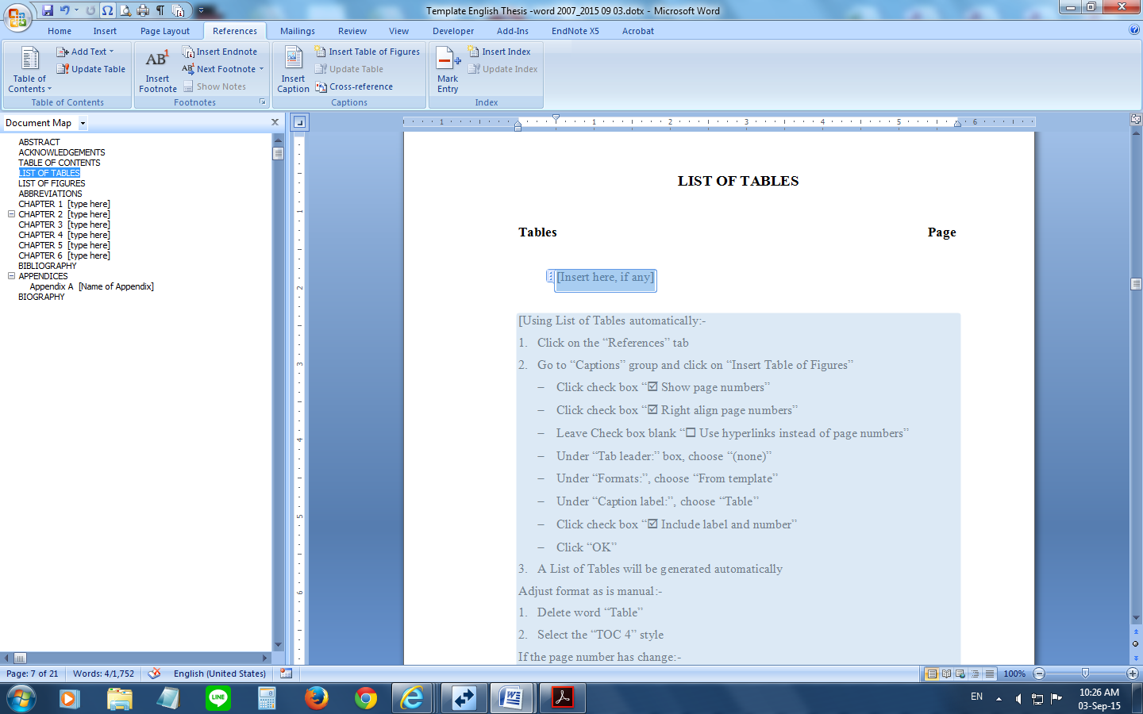
If the page number has changed:-
    - Click on the “References” tab
    - Go to “Table of contents” group, click on “Update Table” and click “Update page numbers only”
    - Click “OK”]

[Do not make changes to the text or page numbers directly in the Table of Contents.]

[Do not delete the “Section Break” below, if you can’t see it, turn on Show/Hide (click to toggle the Show/Hide display on and off)]

LIST OF TABLES
Page

[Insert here, if any]

[Using List of Tables automatically:-
- Click on the “References” tab
- Go to “Captions” group and click on “Insert Table of Figures”
- Click check box “ Show page numbers”
- Click check box “ Right align page numbers”
- Leave Check box blank “ Use hyperlinks instead of page numbers”
- Under “Tab leader:” box, choose “(none)”
- Under “Formats:”, choose “From template”
- Under “Caption label:”, choose “Table”
- Click check box “ Include label and number”
- Click “OK”
- A List of Tables will be generated automatically
Adjust format as is manual:-
- Delete word “Table”
- Select the “TOC 4” style
If the page number has change:-
- Click on the “References” tab
- Go to “Captions” group, click on “Update Table” and click “Update page numbers only”
- Click “OK”]

[Do not delete the “Section Break” below, if you can’t see it, turn on Show/Hide (click to toggle the Show/Hide display on and off)]

LIST OF FIGURES
Page

[Insert here, if any]

[Do not delete the “Section Break” below, if you can’t see it, turn on Show/Hide (click to toggle the Show/Hide display on and off)]

ABBREVIATIONS
Abbreviations Equivalence

[Type here] [Type here]

[Remove page if there is no content]

[Do not delete the “Section Break” below, if you can’t see it, turn on Show/Hide (click to toggle the Show/Hide display on and off)]

CLICK HERE TO ENTER TEXT

Heading2

Click here to enter text use style Paragraph H2

Heading3
Click here to enter text use style Paragraph H3

Click here to enter text

Heading 2

Click here to enter text use style Paragraph H2

Heading 3
Click here to enter text use style Paragraph H3

Click here to enter text

Heading 2

Click here to enter text use style Paragraph H2

Heading 3
Click here to enter text use style Paragraph H3

Click here to enter text

Heading 2

Click here to enter text use style Paragraph H2

Heading 3
Click here to enter text use style Paragraph H3

Click here to enter text

Heading 2

Click here to enter text use style Paragraph H2

Heading 3
Click here to enter text use style Paragraph H3

BIBLIOGRAPHY
Start here use Style Bibliography Entry

APPENDICES

- Name of Appendix

[Add a new Appendix:-
1. Insert a “Section Breaks”
2. Place the cursor at the end of each appendix
3. Click on the “Page Layout” tab, move to the “Page Setup” group, click on “Breaks”
4. Under “Section Breaks”, select “Next Page”
5. The section break will be put in
6. Click on the “Home” tab, move to the “Styles” group arrow to display the window “Styles” and select “Appendix” style
7. The word "Appendix" and number of Appendix will be display automatically, press hold <Shift> and press <Enter> twice
8. Type the name of the appendix]

[If only appendix use the “HEADINGS” style]

[Do not delete the “Section Break” below, if you can’t see it, turn on Show/Hide (click to toggle the Show/Hide display on and off)]

BIOGRAPHY
NAME [Mr./Mrs./Miss First name Last name]

academic background [Type here]

present position [Type here]

