[Dissertation/Thesis TITLE (type the first line longer than the second line)]

[First name Last name (Do not enter the prefix)]

A Dissertation/Thesis Submitted in Partial

**Fulfillment of the Requirements for the Degree of**

Doctor/Master of [Name of Degree] ([Name of Program if available])

[School/Faculty Name]

National Institute of Development Administration

[Academic Year]

[Dissertation/thesis title (type the first line longer than the bottom line)]

[First name Last name (Do not enter the prefix)]

[School/Faculty Name]

[Academic Position] Major Advisor

([First name Last name, Degree])

[Academic Position] Co-Advisor

([First name Last name, Degree])

The Examining Committee Approved This Dissertation/Thesis Submitted in Partial Fulfillment of the Requirements for the Degree of [Name of Degree] ([Name of Program if available])

[Academic Position] Committee Chairperson

([First name Last name, Degree])

[Academic Position] Committee

([First name Last name, Degree])

[Academic Position] Committee

([First name Last name, Degree])

ABSTRACT

**Title of** **Dissertation/Thesis** [Title of dissertation/Thesis]

**Author** [Mr./Mrs./Miss First name Last name]

**Degree** [Title of Degree] ([Program if available])

**Year** [Academic Year (numbers only)]

[Start here (1-2 pages]

[Do not delete the “Section Break” below, if you can’t see it, turn on Show/Hide (click 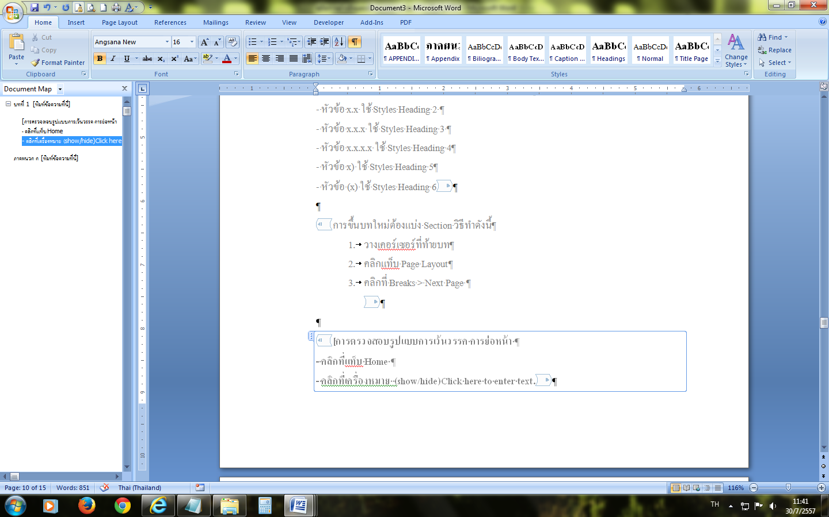 to toggle the Show/Hide display on and off)]

ACKNOWLEDGEMENTS

[Start here (only page)]

[First name Last name]

[Month Year]

[Do not delete the “Section Break” below, if you can’t see it, turn on Show/Hide (click  to toggle the Show/Hide display on and off)]

TABLE OF CONTENTS

**Page**

[Insert here]

[Using Table of Content automatically:-

1. Click on the “References” tab
2. Go to “Table of Contents” group, click on “Table of Contents” and select “Insert Table of Contents”

* Click check box “🗹 Show page numbers”
* Click check box “🗹 Right align page numbers”
* Leave Check box “🞎 Use hyperlinks instead of page numbers”
* Under “Tab leader:” box, choose “(none)”
* Under “Formats:” box, choose “From template”
* Under “Show levels:” box, choose “2”

1. Click “Options” button and setting as follow:-
   * Under “APPENDICES” box, type “1”
   * Under “Appendix” box, type “2”
   * Under “Heading 1” box, type "1”
   * Under “Heading 2” box, type “2”
   * Under “HEADINGS” box, type “1”
   * Make sure no other boxes are check
   * Click “OK”
2. Click “OK”
3. A Tables of Content will be generated automatically

Adjust format as is manual:-

1. Insert the parentheses at page numbers of the first part, such as ABSTRACT (1), ACKNOWLEDGEMENTS (2)….
2. Place the cursor in front of “CHAPTER 1”, press <Enter>
3. Insert a space separate word “CHAPTER 1, 2, 3… and the name of chapter
4. Place the cursor in front of “BIBLIOGRAPHY” and press <Enter>
5. Place the cursor in front of “Appendix A, B, C… and select the “TOC 3” style
6. Place the cursor separate word “Appendix A, B, C… and the name of Appendix, and press <Tab>

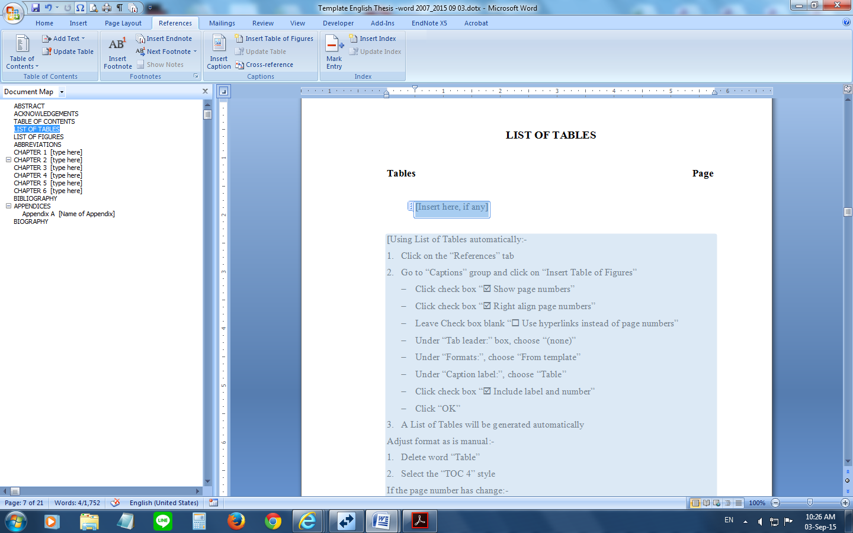If the page number has changed:-

* + 1. Click on the “References” tab
    2. Go to “Table of contents” group, click on “Update Table” and click “Update page numbers only”
    3. Click “OK”]

[Do not make changes to the text or page numbers directly in the Table of Contents.]

[Do not delete the “Section Break” below, if you can’t see it, turn on Show/Hide (click  to toggle the Show/Hide display on and off)]

LIST OF TABLES

**Tables** **Page**

[Insert here, if any]

[Using List of Tables automatically:-

1. Click on the “References” tab
2. Go to “Captions” group and click on “Insert Table of Figures”

* Click check box “🗹 Show page numbers”
* Click check box “🗹 Right align page numbers”
* Leave Check box blank “🞎 Use hyperlinks instead of page numbers”
* Under “Tab leader:” box, choose “(none)”
* Under “Formats:”, choose “From template”
* Under “Caption label:”, choose “Table”
* Click check box “🗹 Include label and number”
* Click “OK”

1. A List of Tables will be generated automatically

Adjust format as is manual:-

1. Delete word “Table”
2. Select the “TOC 4” style

If the page number has change:-

1. Click on the “References” tab
2. Go to “Captions” group, click on “Update Table” and click “Update page numbers only”
3. Click “OK”]

[Do not delete the “Section Break” below, if you can’t see it, turn on Show/Hide (click  to toggle the Show/Hide display on and off)]

LIST OF FIGURES

**Figures** **Page**

[Insert here, if any]

[Do not delete the “Section Break” below, if you can’t see it, turn on Show/Hide (click  to toggle the Show/Hide display on and off)]

ABBREVIATIONS

**Abbreviations** **Equivalence**

[Type here] [Type here]

[Remove page if there is no content]

[Do not delete the “Section Break” below, if you can’t see it, turn on Show/Hide (click  to toggle the Show/Hide display on and off)]

# [type here]

[Start here]

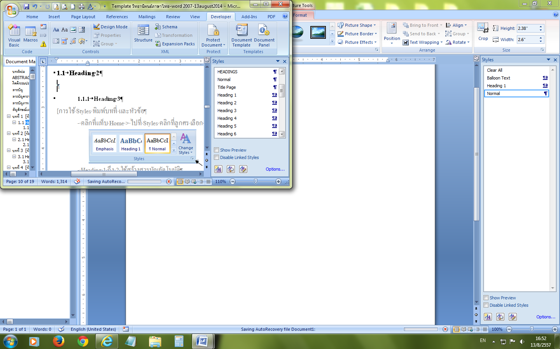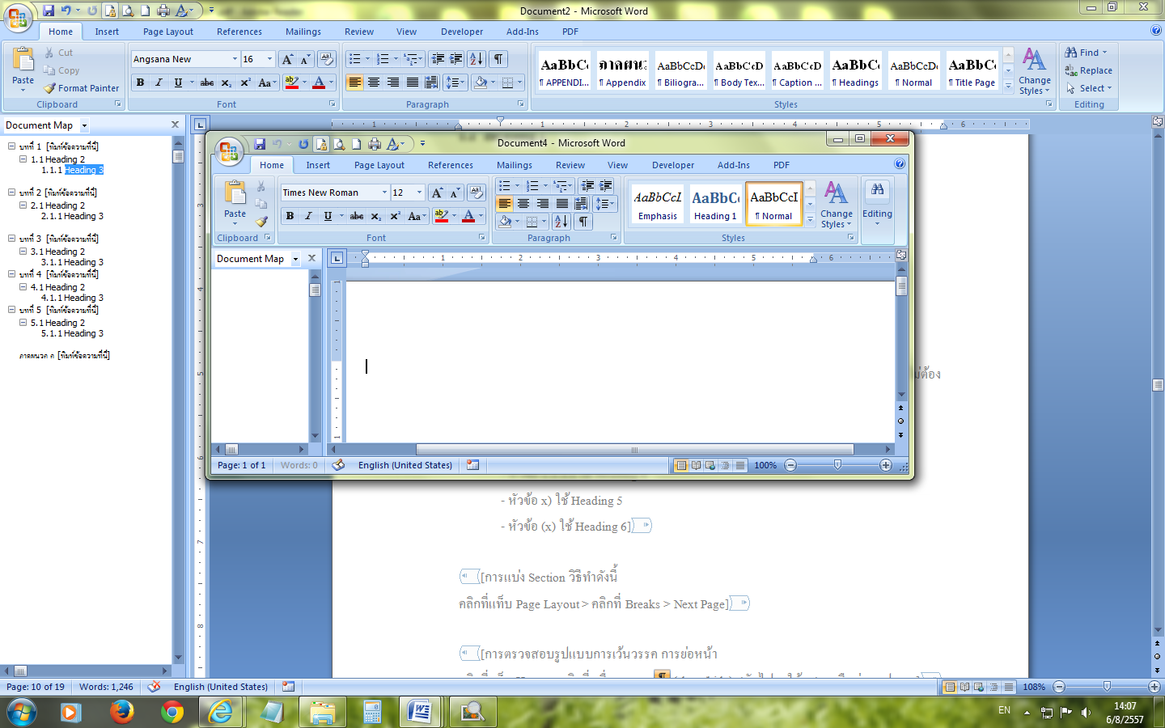

[Using styles:-

1. Place the cursor where you want to insert
2. Click on the “Home” tab, move to the “Styles” group arrow to display the window “Styles” and select style
3. The headings ABSTRACT, ACKNOWLEDGMENTS, TABLE OF CONTENTS, LIST OF TABLES, LIST OF FIGURES, ABBREVIATIONS use the “HEADINGS” style
4. The first page of each CHAPTER use the “Heading 1” style
5. “Heading 2” style use for subheading e.g. 1.1, 2.1
6. “Heading 3” style use for subheading e.g. 1.1.1, 2.1.1
7. “Heading 4” style use for subheading if used e.g. 1.1.1.1, 2.1.1.1
8. “Heading 5” style use for subheading if used e.g. 1), 2)
9. “Heading 6” style use for subheading if used e.g. (1), (2)
10. The headings BIBLIOGRAPHY, APPENDIX (only appendix) and BIOGRAPHY use “HEADINGS” style
11. The headings Appendix A, B, C ... use the “Appendix” style

Notice: The “Heading 1” and “Heading 2” style to create a “Table of Contents” automatically]

[Add a new chapter:-

1. Insert a “Section Breaks”
2. Place the cursor at the end of text
3. Click on the “Page Layout” tab, move to the “Page Setup” group, click on “Breaks”
4. Under “Section Breaks”, select “Next Page”
5. The section break will be put in
6. Click on the “Home” tab, move to the “Styles” group arrow to display the window “Styles” and select the “Heading 1” style
7. The word "CHAPTER" and number of chapter will be display automatically, press hold <Shift> and press <Enter> twice
8. Type the name of the chapter

[Do not delete the “Section Break” below, if you can’t see it, turn on Show/Hide (click  to toggle the Show/Hide display on and off)]

# [type here]

[Start here]

[Typing the name of Tables and Figures in text:-

1. Place the cursor on top of the Table or bottom of the Figure
2. Click on the “References” tab
3. Go to the “Captions” group and click on “Insert Caption”
4. Click “New Label” button, type “Table” or “Figure” and click “OK”
5. Leave check box blank “□ Exclude label from caption”
6. Click “Numbering” button
   * Click check box “🗹 Include chapter number”
   * Under “Chapter starts with style” box, choose the “Heading 1” style
   * Under “Use separator” box, choose “(period)”and click “OK”
7. Click “OK”
8. The word "Table" or "Figure" and number will be display automatically, select the “Caption Table” style or the “Caption Figure” style
9. Press <Tab>, adjust font are not bold and type the name of Table or name of Figure]

[Do not delete the “Section Break” below, if you can’t see it, turn on Show/Hide (click  to toggle the Show/Hide display on and off)]

# [type here]

[Start here]

[Do not delete the “Section Break” below, if you can’t see it, turn on Show/Hide (click  to toggle the Show/Hide display on and off)]

# [type here]

[Start here]

[Do not delete the “Section Break” below, if you can’t see it, turn on Show/Hide (click  to toggle the Show/Hide display on and off)]

# [type here]

[Start here]

[Do not delete the “Section Break” below, if you can’t see it, turn on Show/Hide (click  to toggle the Show/Hide display on and off)]

# [type here]

[Start here]

[Do not delete the “Section Break” below, if you can’t see it, turn on Show/Hide (click  to toggle the Show/Hide display on and off)]

BIBLIOGRAPHY

[This format is base on NIDA style]

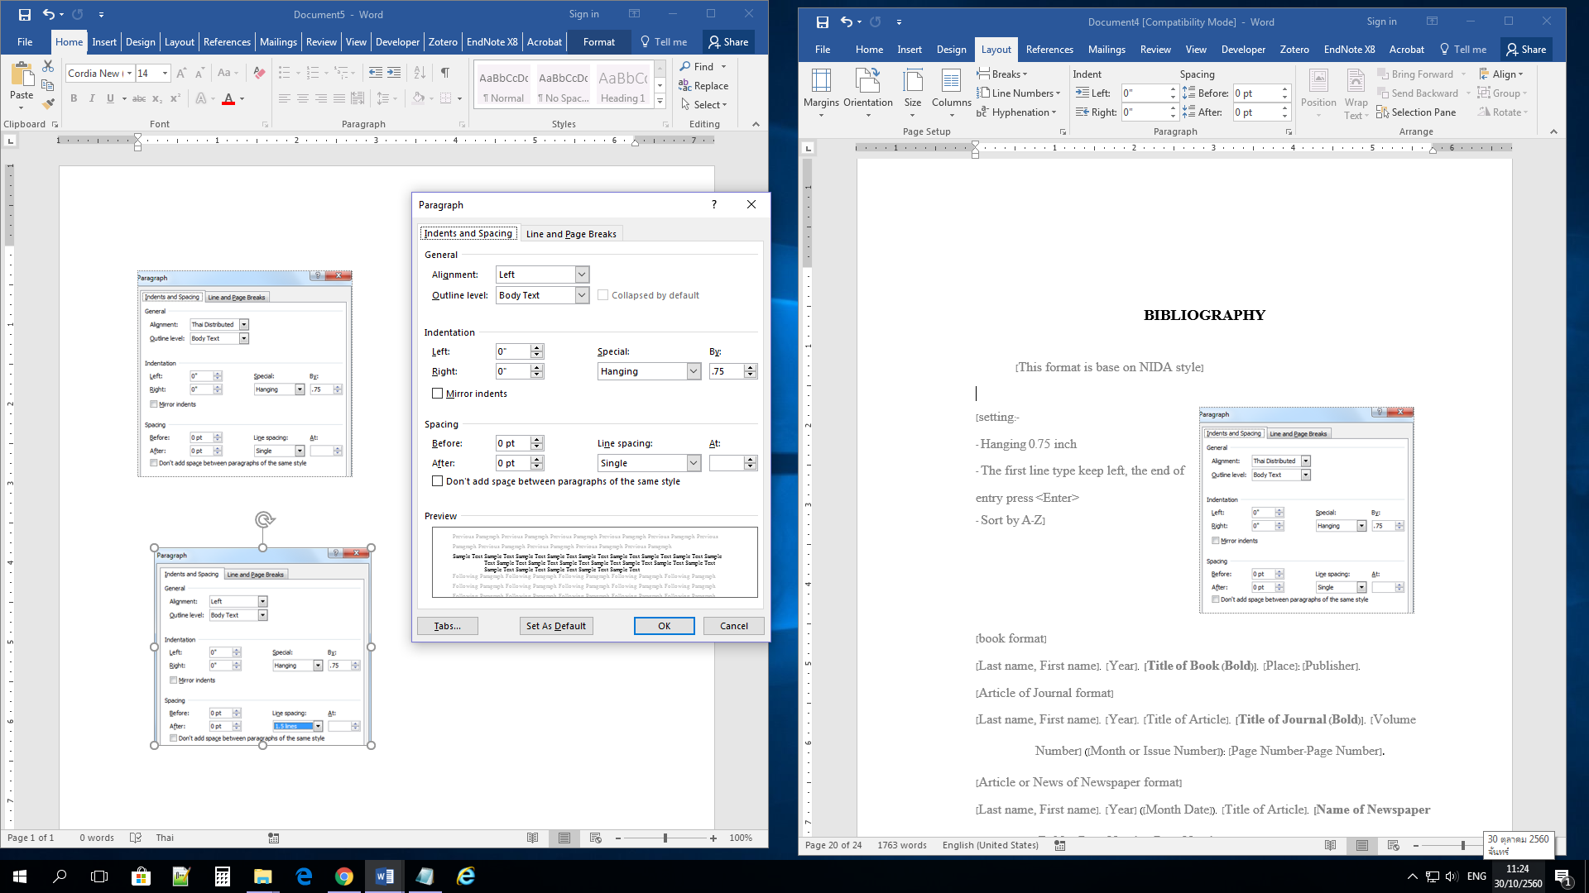

[setting:-

- Hanging 0.75 inch

- The first line type keep left, the end of entry press <Enter>

- Sort by A-Z]

[book format]

[Last name, First name]. [Year]. **[Title of Book (Bold)]**. [Place]: [Publisher].

[Article of Journal format]

[Last name, First name]. [Year]. [Title of Article]. **[Title of Journal (Bold)]**. [Volume Number] ([Month or Issue Number]): [Page Number-Page Number].

[Article or News of Newspaper format]

[Last name, First name]. [Year] ([Month Date]). [Title of Article]. **[Name of Newspaper (Bold)]**: [Page Number-Page Number].

**[Name of Newspaper (Bold)]**. [Year] ([Month Date]). [Title of Article or Title of News]: [Page Number-Page Number].

[Thesis format]

[Last name, First name]. [Academic Year]. **[Title of Thesis (Bold)]**. Master’s thesis, [Name of University].

[Dissertation format]

[Last name, First name]. [Academic Year]. **[Title of Dissertation (Bold)]**. Doctoral dissertation, [Name of University].

[Termpaper format]

[Last name, First name]. [Academic Year]. **[Title of Termpaper (Bold)]**. Termpaper Faculty of [Name of Faculty] [Name of University].

[Secondary Source format]

[Last name, First name of Primary Source]. [Year of Primary Source]. Quoted in [Last name, First name of Secondary Source]. [Year of Secondary Source]. **[Title of Book (Bold)]**. [Place]: [Publisher]. Page [Page Number-Page Number].

[Web Site format]

[Last name, First name]. [Year of Post]. **[Title of Document (Bold)]**. Retrieved [Month Date, Year of Search] from [URL]

[Do not delete the “Section Break” below, if you can’t see it, turn on Show/Hide (click  to toggle the Show/Hide display on and off)]

APPENDICES

1. [Name of Appendix]

[Add a new appendix:-

1. Insert a “Section Breaks”
2. Place the cursor at the end of each appendix
3. Click on the “Page Layout” tab, move to the “Page Setup” group, click on “Breaks”
4. Under “Section Breaks”, select “Next Page”
5. The section break will be put in
6. Click on the “Home” tab, move to the “Styles” group arrow to display the window “Styles” and select “Appendix” style
7. The word "Appendix" and number of Appendix will be display automatically, press hold <Shift> and press <Enter> twice
8. Type the name of the appendix]

[If only appendix use the “HEADINGS” style]

[Do not delete the “Section Break” below, if you can’t see it, turn on Show/Hide (click  to toggle the Show/Hide display on and off)]

BIOGRAPHY

**NAME** [Mr./Mrs./Miss First name Last name]

**academic background** [Type here]

**present position** [Type here]